
Functional Specification & Solution Blueprint
April 2026

<BiDE – Booking & Instructor Dispatch Engine>

<Essential Minds>
<Lethabo Mathole>
<Hlomani Lloyd Mashimbye>
<Awonke Gana>

1 SYSTEM OVERVIEW 7
1.1 Problem Description 7
1.2 Business Rules / Assumptions 7
1.3 System Constraints 7
2 FUNCTIONAL REQUIREMENTS 9
2.1 Initial Use Case Model 9
2.2 Final Use Case Model 10
2.3 Use Case Glossary and Responsibilities 11
2.4 Use Case Narratives & UI Designs 12
2.4.1 Team Designs 12
2.4.1.1 Team User Interface Guidelines 12
2.4.1.2 Login / Logout Feature 12
2.4.1.3 Dashboard / Landing Page / Main Page 13
2.4.2 Individual Crew Member Use Case Narratives & UI Designs 17
2.4.2.1 Designed by <Hlomani Mashimbye> 17
2.4.2.2 Designed by <Hlomani Mashimbye> 18
2.4.2.3 Designed by <Hlomani Mashimbye> 20
2.4.2.4 Designed by <Hlomani Mashimbye> 22
2.4.2.5 Designed by <Hlomani Mashimbye> 22
2.4.2.6 Designed by <Lethabo Mathole> 23
2.4.2.7 Designed by <Lethabo Mathole> 25
2.4.2.8 Designed by <Lethabo Mathole> 25
2.4.2.9 Designed by <Awonke Gana> 27
2.4.2.10 Designed by <Lethabo Mathole> 28
2.4.2.11 Designed by <Awonke Gana> 29
2.4.2.12 Designed by <Awonke Gana> 31
2.4.2.13 Designed by <Lethabo Mathole> 32
2.4.2.14 Designed by <Awonke Gana> 33
2.4.2.15 Designed by <Lethabo Mathole> 34
2.4.2.16 Designed by <Hlomani Mashimbye> 36
2.4.2.17 Designed by <Hlomani Mashimbye> 37
2.4.2.18 Designed by <Lethabo Mathole> 39
2.4.2.19 Designed by <Awonke Gana> 40
2.4.2.20 Designed by <Awonke Gana> 41
3 DATA REQUIREMENTS 42
3.1 List of data and attributes 42
3.2 Domain Class Diagram Error! Bookmark not defined.
3.3 Draft Implementation Ready Class Diagram 44
3.4 Implemented database structure 46
4 TECHNICAL REQUIREMENTS 47
4.1 System Environment 47
4.1.1.1 Operating Environment 47
4.1.1.2 Development Tools and Technologies 47
4.1.1.3 Additional Components (DLLs / Libraries) 47
4.1.1.4 Recommended Screen Resolution 47
4.1.1.5 Other Requirements 47
4.2 Start-up Instructions 48
4.3 Logins & Passwords 48

SYSTEM OVERVIEW

Problem Description

Many individuals who want to learn how to drive experience difficulties in finding reliable, affordable, and accessible driving instructors. Currently, there is no centralized platform that allows learners to easily search for instructors based on location, price, availability, and experience. As a result, learners often rely on informal methods such as word-of-mouth, social media, or messaging platforms, which are inefficient and lack transparency.
At the same time, experienced driving instructors who are willing to offer lessons lack a structured platform to list their services, manage bookings, or track student progress. This leads to missed opportunities, poor scheduling, and ineffective communication between students and instructors.
Therefore, the objective of this project is to develop a Bidirectional Driving Lesson Marketplace System that connects Individuals who want to learn how to drive (Students) and Experienced drivers who want to offer driving lessons (Instructors). The system acts as a two-sided platform where both students and instructors interact through searching, reviewing, and flexible scheduling for both single and multi-session bookings.

Business Rules / Assumptions
- A student must register and have a verified account before making a booking request.
- An instructor must apply and be approved by an administrator before appearing in search results.
- A booking request is only confirmed after payment proof has been uploaded by the student and verified by the instructor.
- A student may only leave a review for a lesson that has been completed.
- A booking may be cancelled or rescheduled subject to system validation.
- An instructor sets up their own availability; bookings can only be requested within those available slots. 7. Payment is handled externally (EFT/cash); only proof of payment is uploaded to the system.
- Each booking is linked to exactly one lesson offering.
- The administrator has full access to manage users, view payments, monitor bookings, and generate reports.

System Constraints
The development of this system is subject to several constraints that may influence the design and implementation:
- The system will be developed as a web-based application only and will not include mobile or desktop versions.
- Payment functionality will be simulated, meaning no real payment gateway or financial transactions will be integrated.
- The system will be developed using the technologies specified in the module (e.g., HTML, CSS, JavaScript, and ASP.NET/MVC), which may limit the use of advanced frameworks or tools.
- The project must be completed within a limited timeframe as defined by the academic schedule.
- The system will operate in a controlled environment and will not include real-world verification of users (e.g., instructor certification validation).
- Data used in the system may be sample or test data, and not actual real-world data.
- The system will support core functionalities such as booking, lesson progress tracking, and reviews, but may not include advanced features such as real-time notifications or integrated messaging.

FUNCTIONAL REQUIREMENTS

Initial Use Case Model
[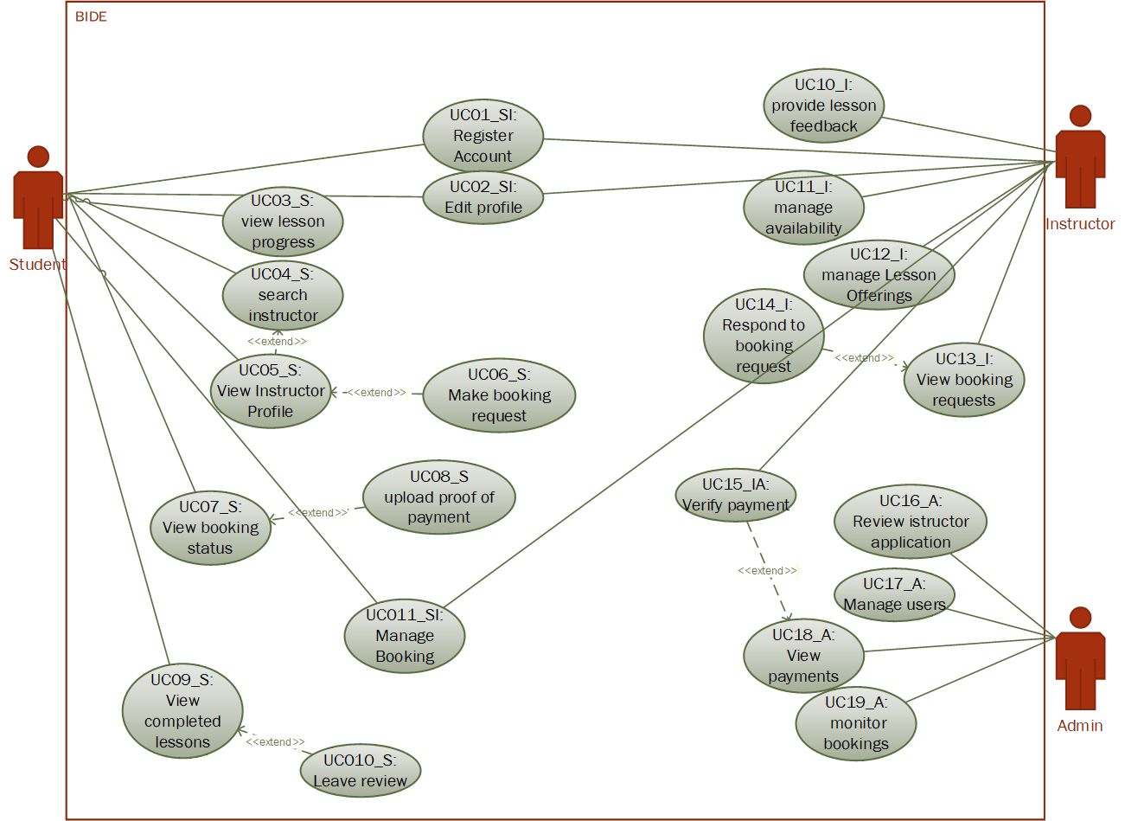]

Final Use Case Model
[Replace this text with the Use Case diagram – this must be drawn in Visio.]

Use Case Glossary and Responsibilities

Allocated to Crew Member: <Hlomani Mashimbye>
Use Case Id | Use Case Name
UC01_SI | Register Account
UC02_SI | Edit Profile
UC03_S | View Lesson Progress
UC04_S | Search Instructor
UC05_S | View Instructor Profile
UC16_A | Review Instructor Application
UC17_A | Manage Users

Allocated to Crew Member: <Lethabo Mathole>
Use Case Id | Use Case Name
UC06_S | Make Booking Request
UC15_I | Verify Payment
UC08_S | Upload Proof of Payment
UC10_S | Leave Review
UC07_S | View Booking Status
UC13_I | View Booking Requests
UC18_A | View Payments

Allocated to Crew Member: Awonke Gana >
Use Case Id | Use Case Name
UC11_SI | Manage Bookings
UC14_I | Respond to Booking Requests
UC20_I | Provide Lesson Feedback
UC11_I | Manage Availability
UC12_I | Manage Lesson Offering
UC09_I | View Completed Lessons
UC19_A | Monitor Bookings

Use Case Narratives & UI Designs

Team Designs

Team User Interface Guidelines

Login / Logout Feature

Initial UI design



Final UI

Dashboard / Landing Page / Main Page

Initial UI design
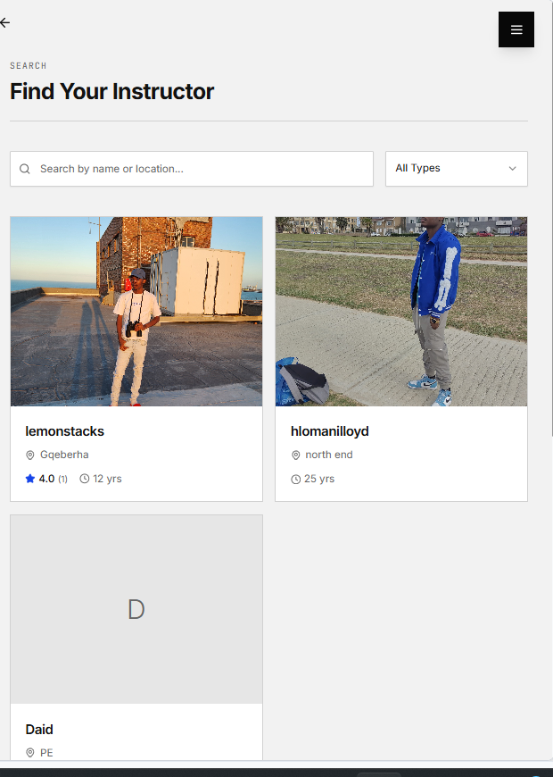

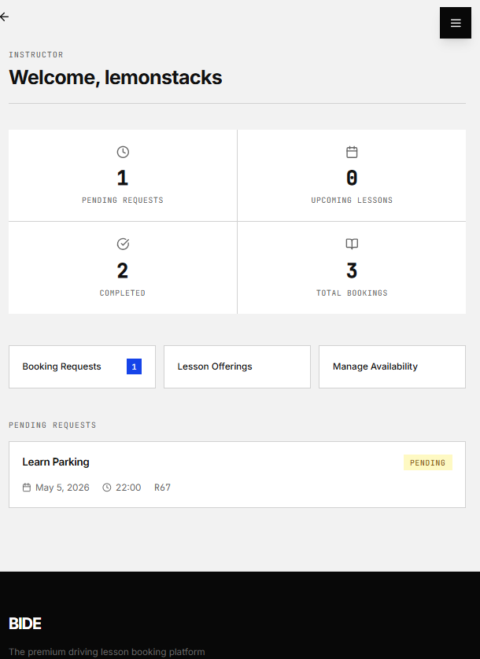
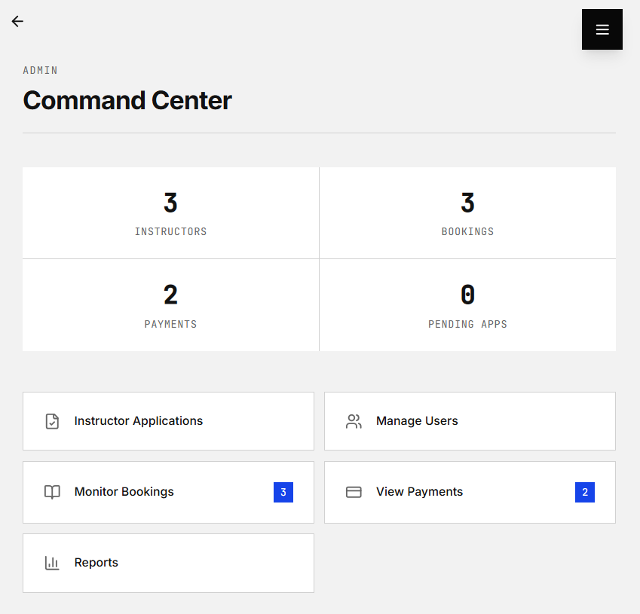

Final UI

Individual Crew Member Use Case Narratives & UI Designs

Designed by <Hlomani Mashimbye>

Use Case ID | Use Case Name
UC01_SI | Register Account
Actors
Student, Instructor
Pre-Conditions | Users are not registered in the system.
Triggers | User selects register option
Post-Conditions | Account is created and stored
Basic Flow of Events / Main Success Scenario
- The actor selects the option to register an account.
- The system displays the registration form.
- The actor enters personal details.
- The system validates the information provided.
- The system creates the account.
- The system displays a confirmation message.
Initial UI Design
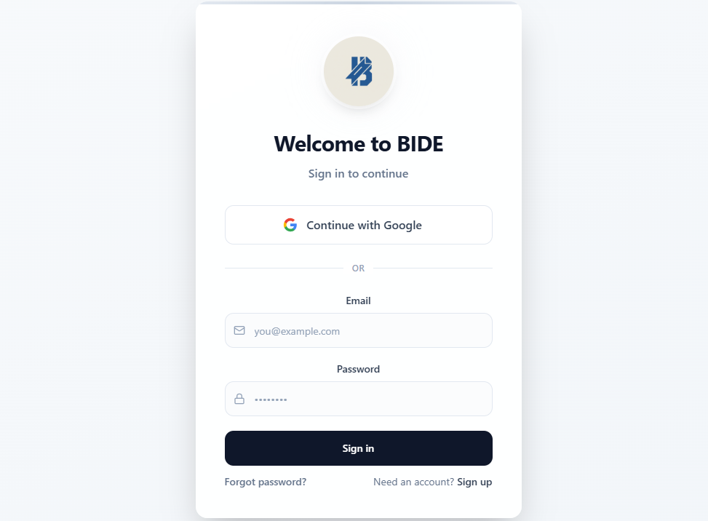
Final Implemented UI Design

Designed by <Hlomani Mashimbye>

Use Case ID | Use Case Name
UC02_SI | Edit Profile
Actors
Student, Instructor
Pre-Conditions | User has an account
Triggers | User selects edit profile
Post-Conditions | Profile information is updated
Basic Flow of Events / Main Success Scenario
- The actor selects the option to edit their profile.
- The system displays current profile information.
- The actor updates the required details.
- The system validates the updated information.
- The system saves the changes.
- The system displays the updated profile.

Initial UI Design

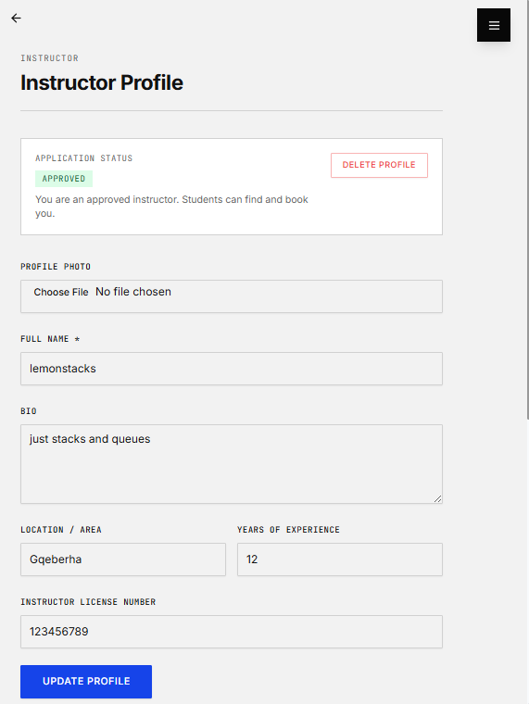
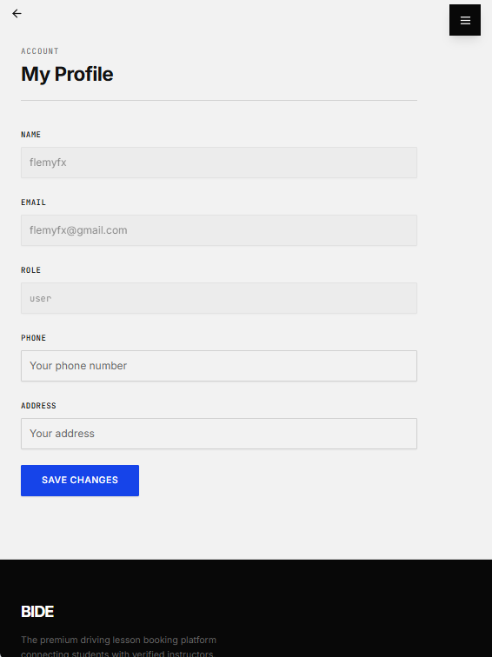
Final Implemented UI Design

Designed by <Hlomani Mashimbye>

Use Case ID | Use Case Name
UC03_S | View Lesson Progress
Actors
Student
Pre-Conditions | User has an account  Student has at least one booking with recorded lesson progress
Triggers | Student selects View Lesson Progress
Post-Conditions | Lesson progress information is displayed
Basic Flow of Events / Main Success Scenario
- The actor selects the option to view lesson progress.
- The system retrieves the student’s booking records.
- The system retrieves associated lesson progress records.
- The system displays lesson details (lesson name, instructor, date, status).
- The system displays all progress records including feedback, rating, and skills covered.
- The system highlights the current lesson status (e.g., In Progress or Completed).

Initial UI Design
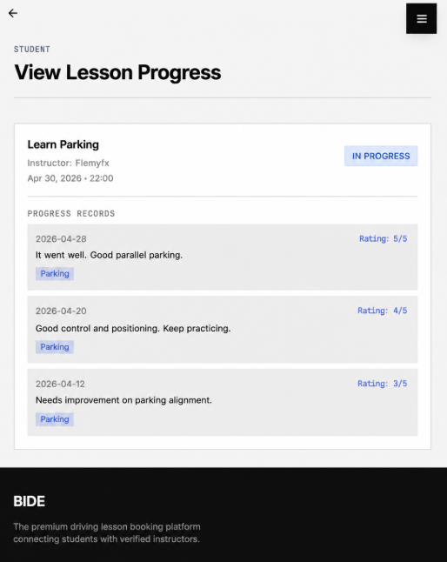
Final Implemented UI Design

Designed by <Hlomani Mashimbye>

Use Case ID | Use Case Name
UC04_S | Search Instructor
Actors
Student
Pre-Conditions | Student account
Triggers | Student enters search criteria
Post-Conditions | Matching instructors are displayed
Basic Flow of Events / Main Success Scenario
- The actor enters search criteria.
- The system processes the request.
- The system retrieves matching instructors.
- The system displays search results.
Initial UI Design
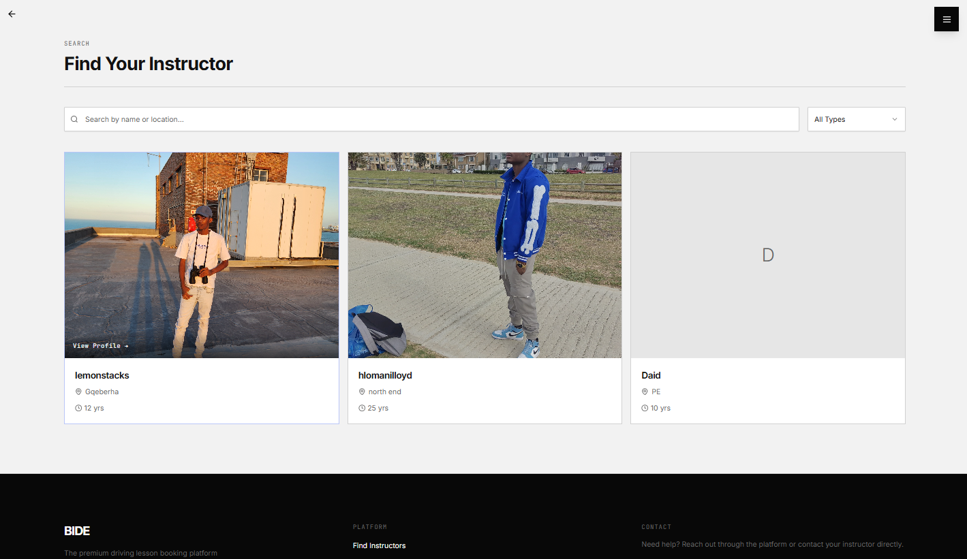
Final Implemented UI Design

Designed by <Hlomani Mashimbye>

Use Case ID | Use Case Name
UC05_S | View Instructor Profile
Actors
Student
Pre-Conditions | Search results are available
Triggers | Student selects an instructor
Post-Conditions | Instructor profile is displayed
Basic Flow of Events / Main Success Scenario
- The actor selects an instructor from the search results.
- The system retrieves the instructor’s profile details.
- The system displays the instructor’s profile.
Initial UI Design
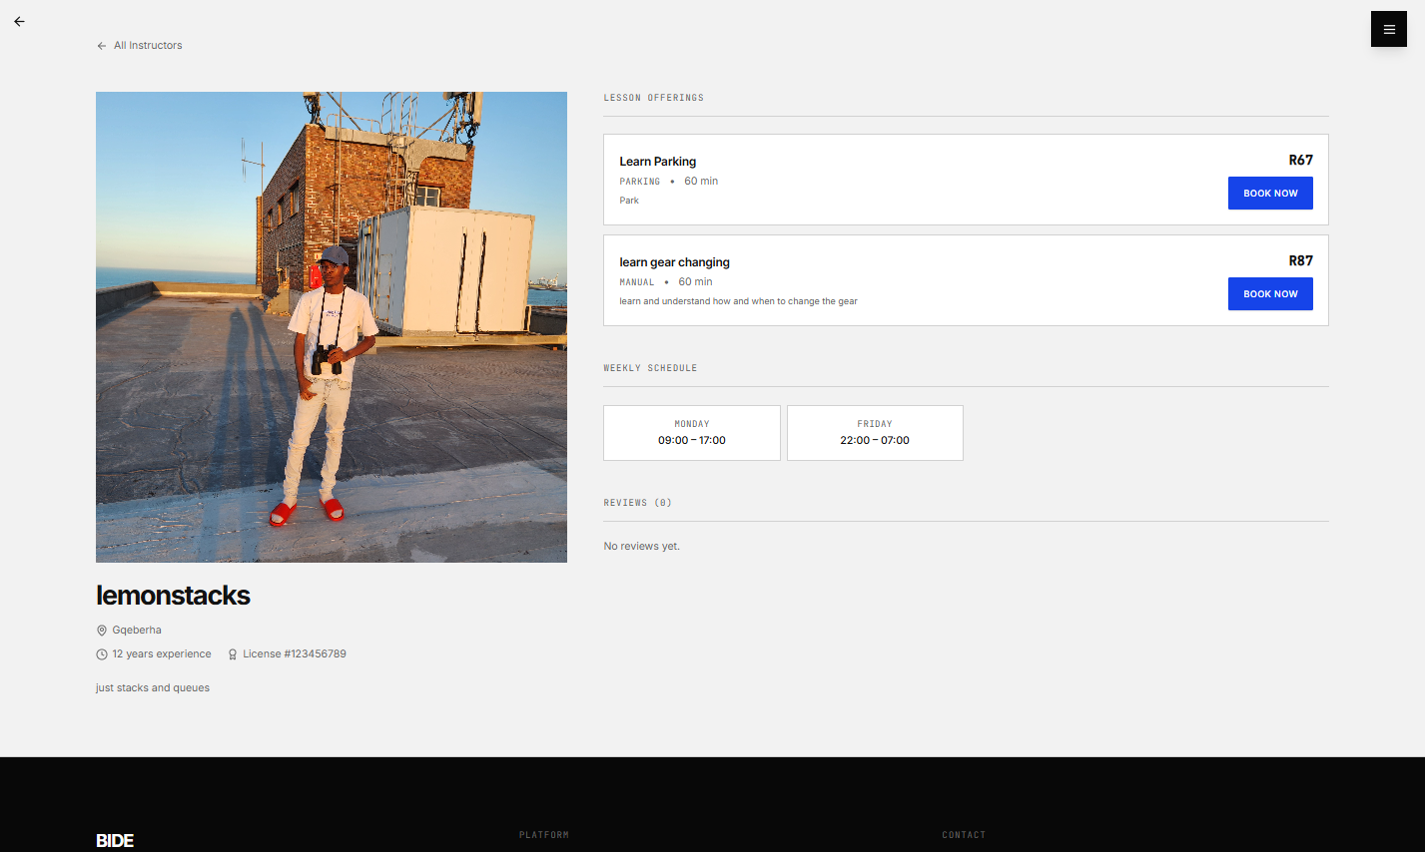
Final Implemented UI Design

Designed by <Lethabo Mathole>

Use Case ID | Use Case Name
UC06_S | Make Booking Request
Actors
Student
Pre-Conditions | Student has viewed an instructor profile
Triggers | Student selects booking option
Post-Conditions | Booking request is recorded as pending
Basic Flow of Events / Main Success Scenario
- The actor selects an instructor.
- The actor selects a preferred date and time.
- The system checks the instructor’s availability.
- The system confirms the selected time slot is available.
- The actor confirms the booking request.
- The system records the booking request.
- The system marks the booking as pending.
- The system displays a confirmation message.
Initial UI Design
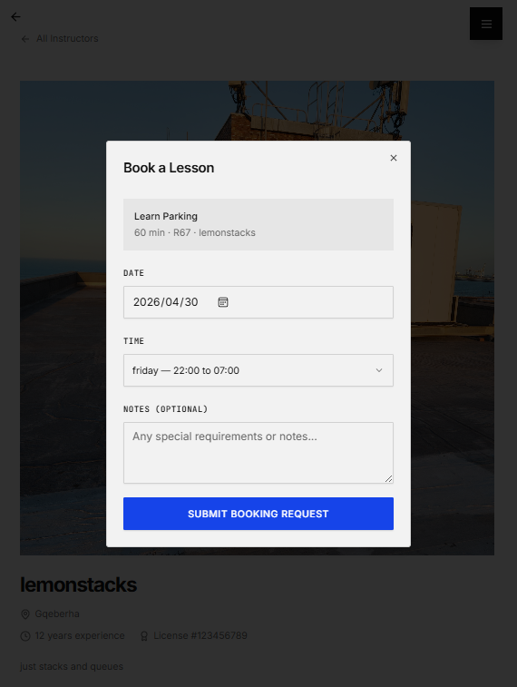
Final Implemented UI Design

Designed by <Lethabo Mathole>

Use Case ID | Use Case Name
UC07_S | View Booking Status
Actors
Student
Pre-Conditions | Student has bookings
Triggers | Student selects booking status option
Post-Conditions | Booking statuses are displayed
Basic Flow of Events / Main Success Scenario
- The actor selects the option to view bookings.
- The system retrieves all booking records.
- The system displays booking statuses.
Initial UI Design
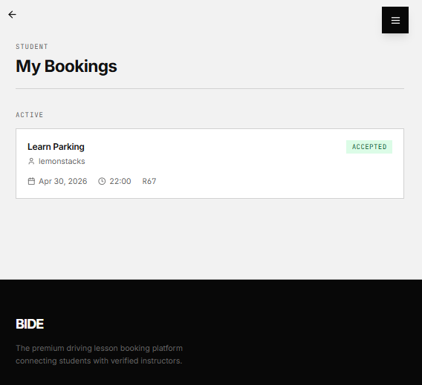
Final Implemented UI Design

Designed by <Lethabo Mathole>

Use Case ID | Use Case Name
UC08_S | Upload Proof of Payment
Actors
Student
Pre-Conditions | A booking request exists
Triggers | Student selects upload option
Post-Conditions | Payment proof is stored
Basic Flow of Events / Main Success Scenario
- The actor selects a booking.
- The system displays booking details.
- The actor uploads proof of payment.
- The system validates the uploaded file.
- The system stores payment proof.
Initial UI Design
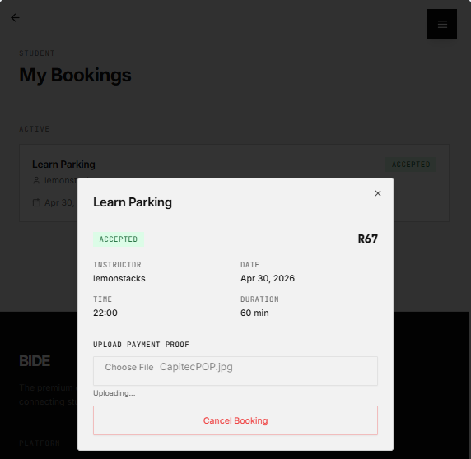
Final Implemented UI Design

Designed by <Awonke Gana>

Use Case ID | Use Case Name
UC09_S | View completed lessons
Actors
Student
Pre-Conditions | Completed lessons exist
Triggers | Student selects completed lessons option
Post-Conditions | Completed lessons are displayed
Basic Flow of Events / Main Success Scenario
- The actor selects the option to view completed lessons.
- The system retrieves completed lesson records.
- The system displays the list of completed lessons
Initial UI Design
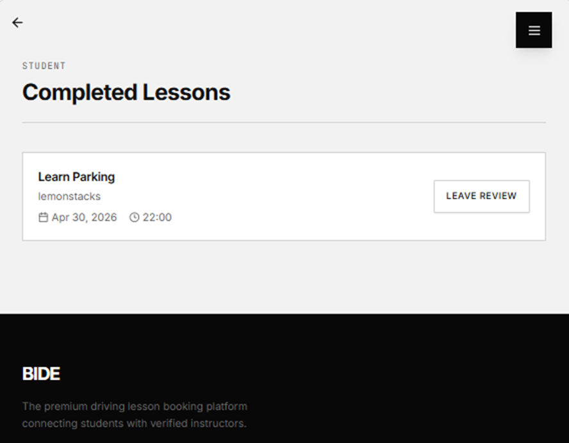
Final Implemented UI Design

Designed by <Lethabo Mathole>

Use Case ID | Use Case Name
UC10_S | Leave Review
Actors
Student
Pre-Conditions | Student has completed a lesson
Triggers | Student selects leave review option
Post-Conditions | Review is saved
Basic Flow of Events / Main Success Scenario
- The actor selects a completed lesson.
- The system displays the review form.
- The actor enters a rating and comment.
- The system validates the review details.
- The system saves the review.
- The system displays a confirmation message.
Initial UI Design
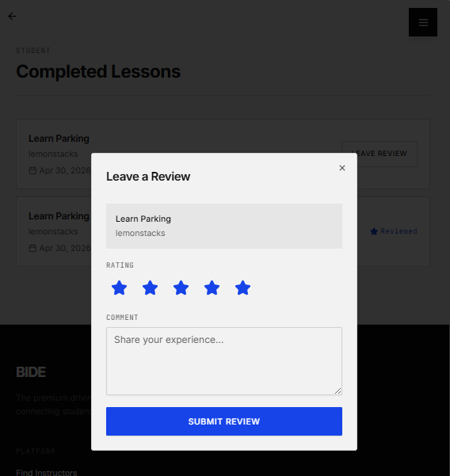
Final Implemented UI Design

Designed by <Awonke Gana>

Use Case ID | Use Case Name
UC11_I | Manage Availability
Actors
Instructor
Pre-Conditions | Instructor account exists
Triggers | Instructor selects availability
Post-Conditions | Availability schedule is updated
Basic Flow of Events / Main Success Scenario
- The actor selects availability settings.
- The system displays current availability.
- The actor updates available time slots.
- The system validates entries.
- The system saves the schedule.
- The system displays updated availability.
Initial UI Design
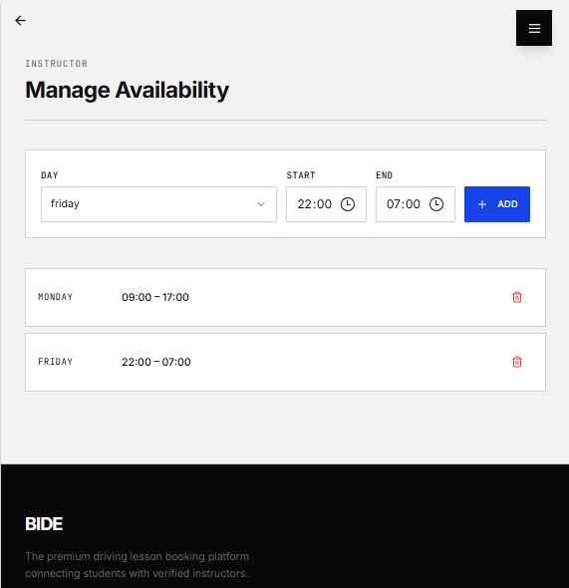
Final Implemented UI Design

Designed by <Awonke Gana>

Use Case ID | Use Case Name
UC12_I | Manage lesson offerings
Actors
Instructor
Pre-Conditions | Instructor account exists
Triggers | Instructor selects lesson offerings
Post-Conditions | Lesson offerings are updated
Basic Flow of Events / Main Success Scenario
- The actor selects lesson offerings.
- The system displays existing offerings.
- The actor adds or edits lesson details.
- The system validates the information.
- The system saves the changes.
- The system displays updated offerings.
Initial UI Design
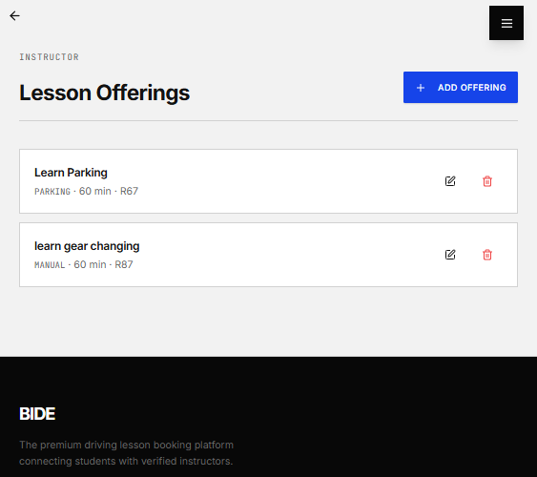
Final Implemented UI Design

Designed by <Lethabo Mathole>

Use Case ID | Use Case Name
UC13_I | View Booking Requests
Actors
Instructor
Pre-Conditions | Booking requests exist
Triggers | Instructor selects booking requests option
Post-Conditions | Booking requests are displayed
Basic Flow of Events / Main Success Scenario
- The actor selects the option to view booking requests.
- The system retrieves all booking requests.
- The system displays the booking request list.
Initial UI Design
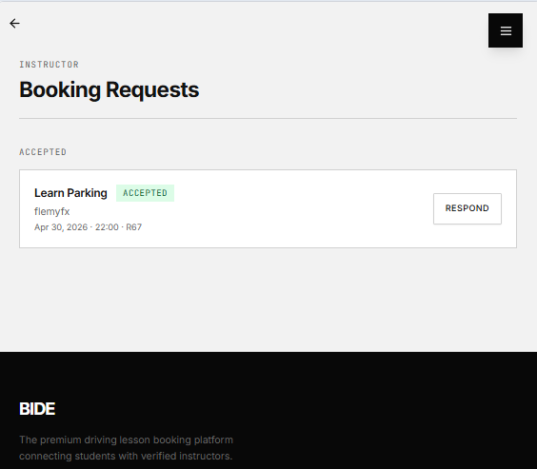
Final Implemented UI Design

Designed by <Awonke Gana>

Use Case ID | Use Case Name
UC14_I | Respond to Booking Request
Actors
Instructor
Pre-Conditions | Booking request exists
Triggers | Instructor selects a request
Post-Conditions | Booking status is updated
Basic Flow of Events / Main Success Scenario
- The actor selects a booking request.
- The system displays request details.
- The actor reviews the request.
- The actor accepts or rejects the request.
- The system updates the booking status.
- The system stores the response.
Initial UI Design
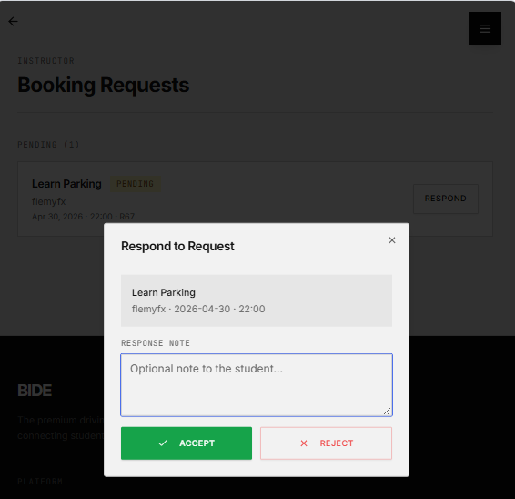
Final Implemented UI Design

Designed by <Lethabo Mathole>

Use Case ID | Use Case Name
UC15_I | Verify Payment
Actors
Instructor
Pre-Conditions | Payment proof is uploaded
Triggers | Instructor selects payment verification
Post-Conditions | Payment is verified or rejected
Basic Flow of Events / Main Success Scenario
- The actor selects a booking with payment proof.
- The system displays the payment details.
- The actor reviews proof of payment.
- The actor verifies or rejects the payment.
- The system updates the payment status.
- The system saves the result.
Initial UI Design
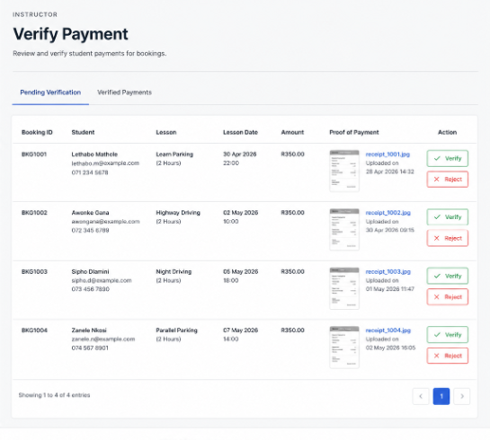
Final Implemented UI Design

Designed by <Hlomani Mashimbye>

Use Case ID | Use Case Name
UC16_A | Review Instructor Application
Actors
Admin
Pre-Conditions | Instructor application exists
Triggers | Admin selects application
Post-Conditions | Application is approved or rejected
Basic Flow of Events / Main Success Scenario
- The actor selects an instructor application.
- The system displays application details.
- The actor reviews the application.
- The actor approves or rejects the application.
- The system updates the application status.
Initial UI Design
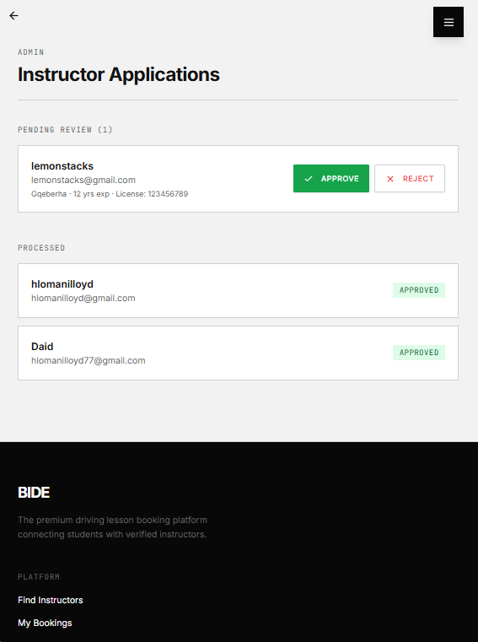
Final Implemented UI Design

Designed by <Hlomani Mashimbye>

Use Case ID | Use Case Name
UC17_A | Manage Users
Actors
Admin
Pre-Conditions | User accounts exist
Triggers | Admin selects user management
Post-Conditions | User records are updated
Basic Flow of Events / Main Success Scenario
- The actor selects user management.
- The system displays all user accounts.
- The actor selects a user account.
- The actor performs an action such as editing or deactivating.
- The system updates the user's record.
- The system saves the changes.
Initial UI Design
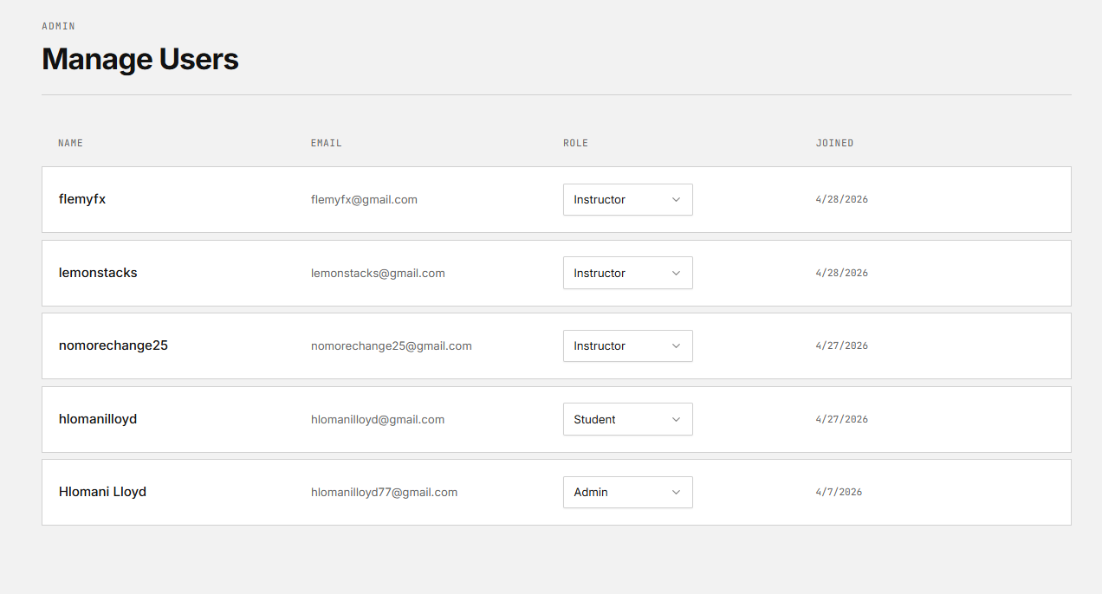
Final Implemented UI Design

Designed by <Lethabo Mathole>

Use Case ID | Use Case Name
UC18_A | View Payments
Actors
Admin
Pre-Conditions | Payments records exist
Triggers | Admin selects payments option
Post-Conditions | Payment details are displayed
Basic Flow of Events / Main Success Scenario
- The actor selects the option to view payments.
- The system retrieves payment records.
- The system displays payment details.
Initial UI Design
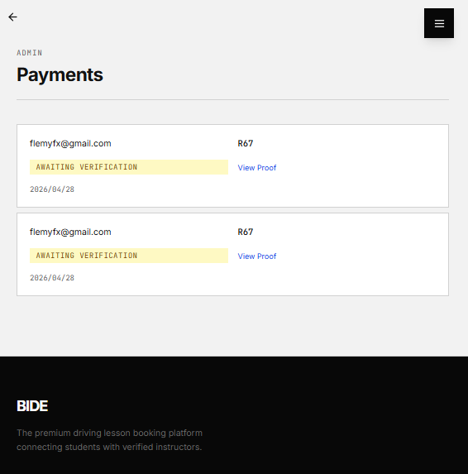
Final Implemented UI Design

Designed by <Awonke Gana>

Use Case ID | Use Case Name
UC19_A | Monitor Bookings
Actors
Admin
Pre-Conditions | Booking records exist
Triggers | Admin selects booking monitoring
Post-Conditions | Booking information is displayed
Basic Flow of Events / Main Success Scenario
- The actor selects booking monitoring.
- The system retrieves booking records.
- The system displays booking information and statuses.
Initial UI Design
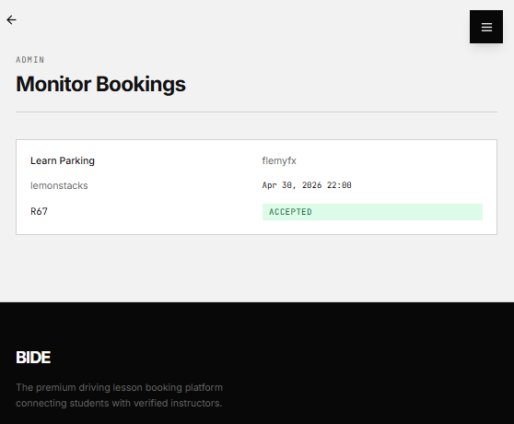
Final Implemented UI Design

Designed by <Awonke Gana>

Use Case ID | Use Case Name
UC20_I | Provide Lesson Feedback
Actors
Instructor
Pre-Conditions | A lesson session associated with a specific booking has been initiated or completed.
Triggers | The Instructor selects the option to add progress.
Post-Conditions | Feedback is stored, displayed, and linked to the student's lesson history.
Basic Flow of Events / Main Success Scenario
- The instructor accesses the lesson progress tab
- The system will display the lesson progress for each lesson.
- The instructor enters qualitative feedback and performance ratings.
- The system saves the feedback record
- The system confirms the feedback has been successfully logged.
Initial UI Design
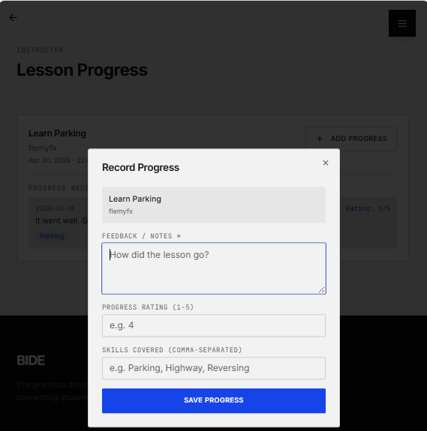
Final Implemented UI Design

DATA REQUIREMENTS

List of data and attributes

Entity | Entity Attributes
Student | studentId: int, licenseNo: String, phone: String, dateOfBirth: Date
Instructor | instructorId: int, licenseNo: String, bio: String, rating: double
Admin | adminId: int, role: String, accessLevel: int
Booking | bookingId: int, date: Date, time: Time, location: String, status: String, duration: int
LessonOffering | offeringId: int, type: String, price: double, duration: int, description: String
Availability | availabilityId: int, dayOfWeek: String, startTime: Time, endTime: Time
Payment | paymentId: int, amount: double, proofFile: String, status: String, verifiedAt: DateTime
Review | reviewId: int, rating: int, comment: String, createdAt: DateTime, bookingId: int
InstructorApplication | applicationId: int, submittedAt: DateTime, status: String, documents: String, reviewedBy: int

Domain Class Diagram
[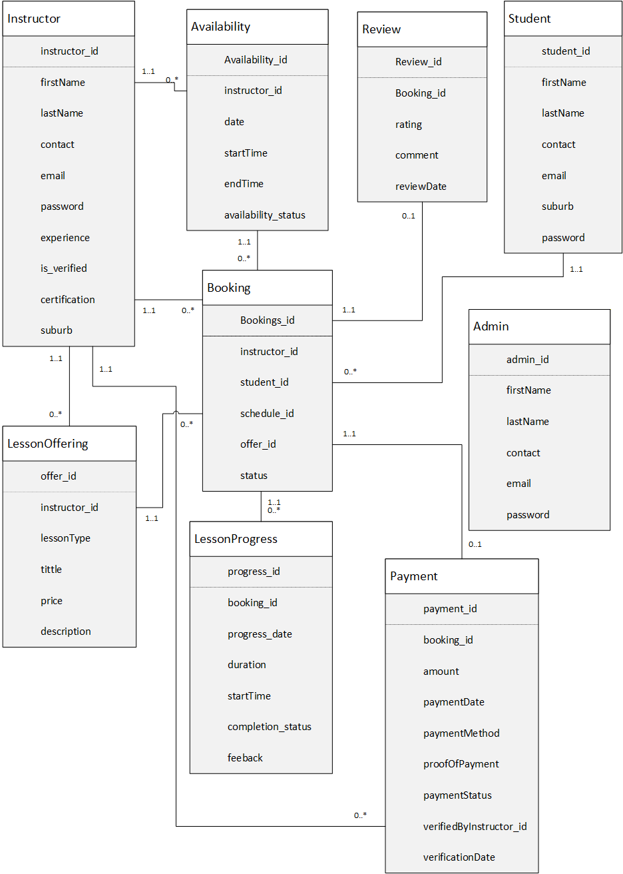]

Draft Implementation Ready Class Diagram

Implemented database structure
We have used <SQL Server> to create our database in.
The name of the database for our project is <BIDE>

[Replace this text with screenshot of the relationship view of the implemented database]

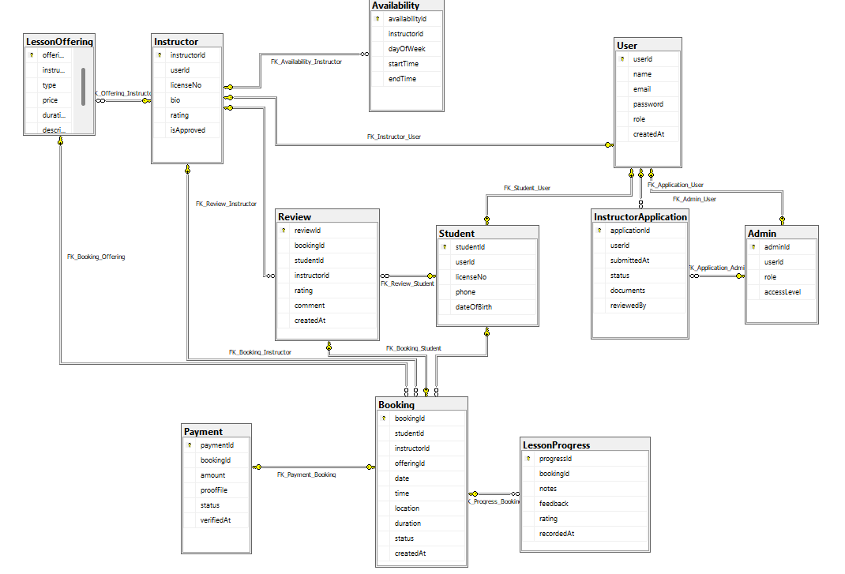

TECHNICAL REQUIREMENTS

System Environment

Operating Environment
The system will be developed and executed as a web-based application. It can run on any modern operating system that supports web browsers, including:
- Windows 10 / Windows 11
- macOS
- Linux
Users will access the system through a web browser such as:
- Google Chrome (recommended)
- Microsoft Edge
- Mozilla Firefox

Development Tools and Technologies
The system will be developed using the following tools and technologies:
- Frontend: HTML5, CSS3, JavaScript
- Backend: ASP.NET MVC
- Programming Language: C#
- Database: SQL Server
- IDE: Visual Studio 2022

Additional Components (DLLs / Libraries)
The following libraries and frameworks may be used:
- .NET Framework / .NET Core libraries
- ASP.NET MVC libraries
- Entity Framework (for database operations)
These libraries are automatically managed within Visual Studio and do not require manual installation by the end user.

Recommended Screen Resolution
For optimal user experience, the recommended screen resolution is:
1366 x 768 or higher
For best display:
1920 x 1080 (Full HD)

Other Requirements
- Internet connection required to access the system An internet
- Basic computer literacy for users
- User must have JavaScript enabled

Start-up Instructions

Logins & Passwords

